**School of Electrical**

**and Electronic Engineering**



**Robot Orchestra**

**Appendices**

**Group 11**

|  |  |  |
| --- | --- | --- |
| Group Members: | Buruiana, Andrei | 9478411 |
|  | Chanda, Joyanto | 9015629 |
|  | Dimou, Theodoros | 9126435 |
|  | Fumagalli, Francesco | 9017237 |
|  | Petrovs, Antons | 9474345 |
|  | Simpson, Joshua | 8929879 |

Tutors: Prof. Danielle George and Dr. William McGenn

Date: 15 May 2018

Table of Contents

Appendix A 3

Appendix I 7

Appendix J 7

Appendix K 7

# Appendix A

**Project Proposal**

**Project Title:** New core infrastructure for the Robot Orchestra

**Supervisors:** Prof Danielle George and Dr William McGenn

**Industrial Involvement:** National Instruments, Siemens, EPSRC, The Granada Foundation

**Overall Aim and Objectives of the Project:**

The aim of this project is to develop a 4-piece (min) robot music band/orchestra with a robot conductor. The Robot Orchestra is a project that fuses engineering with music/arts in order to give people a new perspective on engineering, highlight the creativity of engineering to prospective employees and reach audiences that are traditionally under-represented in the engineering sector. The instruments in the current orchestra have been made by school children, university students, maker groups and other members of the public, and use a wide variety of software and hardware platforms.

This project will involve building and developing a new core infrastructure for the Robot Orchestra that will be stand-alone as well as increase the flexibility, usability and reliability of the existing orchestra. This will include building a new robotic conductor as well as building several new instruments and developing others to form a centre piece for the orchestra. These instruments should allow for as large a range of musical styles to be played as possible. This new core infrastructure for the Robot Orchestra should be usable independently or with existing instruments and any new instruments, irrespective of the hardware platform that has been used to build them.

**Tasks to be undertaken** (a list is preferred and brief explanation if necessary)

* The new core for the robot orchestra should consist of at least 4 instruments/robots; these can either be built from scratch or developed from pre-existing instruments in the orchestra. These should have visual elements as well as being musical in order to increase the visual appeal of the orchestra. The instruments chosen should allow for the core orchestra to be capable of playing a wide variety of styles of music.
* It is worth noting that the challenges involved will differ depending on the instruments chosen and the way that the instruments are played. Careful selection of the instruments and their implementation into robots will be one of the key challenges for the team, not only on a technical level but it is also a key challenge for the project management.
* Develop a conductor for controlling all of the instruments/robots, which should be capable of controlling those that are being built as part of this project, those that already exist in the orchestra and also have as much flexibility as possible to include any that could be built in the future.
* In order to increase the ease of use of the orchestra we would like to develop a common MIDI file interface for the conductor and the other instruments (where appropriate).
* In order to increase the flexibility of the orchestra, we would like the orchestra to be programmed to play a selection of different pieces of music (to be chosen and justified by the team) that will appeal to a range of different ages and tastes in music, and could also be used in different situations (during Robot Orchestra performances, live shows and demonstrations).

**Relevant Background Information** (attach as separate if necessary)

The Robot Orchestra is an EPSRC-funded outreach project led by Professor Danielle George at The University of Manchester, in collaboration with Siemens and the Granada Foundation plus many more. The project originally began as to celebrate Manchester being the 2016 European City of Science and has continued to develop this year. In 2017 the BBC filmed the orchestra on a number of occasions including at Maida Vale Studios in London.

The orchestra has been part of a UK engineering tour sponsored by the Royal Academy of Engineering and showcased at both the institution of Engineering and Technology and the Institution of Mechanical Engineers. It is envisioned that the professional standards of the Meng teams output will attract further attention from the professional bodies as well as industry.

**Other Information**

To give an idea of range of musical styles, currently the orchestra is set up to play Hall of the Mountain King (https://www.youtube.com/watch?v=kLp_Hh6DKWc) and Ed Sheeran’s Shape of You (https://www.youtube.com/watch?v=_dK2tDK9grQ). It is not necessary that the new orchestra developed as part of this project need to play either of the songs.

During performances the audience is generally made award of the experimental nature of the current orchestra and will as such give allowances for some technical/musical mishaps. However part of the aim of this project is to reduce the experimental nature of the orchestra as much as possible, and thereby minimising both technical and musical problems.

**More information about the Robot Orchestra can be found at the website and on social media**

Website: http://www.robotorchestra.co.uk

Instagram: https://www.instagram.com/robotsarecoming/

Twitter: http://twitter.com/robotsmcr (@robotsmcr)

In addition there are a number of films of the orchestra performing and that we have been included in

The Making of the Robot Orchestra: <https://www.youtube.com/watch?v=SQdIGueRKj4>

The Robot Orchestra at the Manchester Science Festival: <https://youtu.be/9v1Jr8TDo0A>

Can a Robot Replace Ed Sheeran? <http://www.bbc.co.uk/programmes/p04sxvgw>

and

<http://www.bbc.co.uk/programmes/articles/55sKXKxMjBb9jdVyRgJXM72/could-a-robot-replace-ed-sheeran>

What if… Robots Replaced Teachers: <http://www.bbc.co.uk/programmes/articles/50xFTZWjLhb0Rv5v76bXsNs/what-if-robots-replaced-teachers>

**Desirable Skills** (note that the majority of the class are EEE students – some skills are in short supply). H,M,L =High, Medium, Low priority.

|  |  |  |
| --- | --- | --- |
| Please fill in as many relevant requirements as you wish **Skills** | **Number of students** | **Priority**  **H,M,L** |
| Power Electronics | | |
| Power Systems | | |
| High Voltage | | |
| FPGA | 1 | M |
| Embedded System | 1 | H |
| Digital Signal Processing | | |
| Image Processing and Vision systems | | |
| Analogue Circuits | 1 | M |
| Software Engineering | 1 | H |
| Control | 1 | M |
| Data Analysis | | |
| Sensors and Instrumentation | 1 | M |
| Communication Systems | 1 | L |
| Silicon Fabrication/Clean room | | |
| Mechatronics | 1 | H |
| Robotics | 1 | M |
| Sensors | | |
| Other (specify) | | |
| Knowledge of music etc (in addition to the above technical skills) | 2 | L |

**Metrics (Norms) for Technical Delivery**

Write a short statement to suggest what a “typical” M.Eng team would be expected to deliver on this project to achieve the following classifications. It is suggested that these statements are based on no more than 10 criteria:

**First Class**

Satisfied the 2:1 level and in addition:

* Full automation
* The finished orchestra is capable of playing, and programmed to play, a wide range of different songs to suit a wide variety of audiences and situations.
* Steps have been taken to ensure that new instruments can be added to this core orchestra in the future without needing the make changes to this core, irrespective of the hardware platforms to be added.
* Investigated further potential developments for increasing the interactivity of the orchestra
* Well thought out solutions for how the orchestra can be transported and set up to minimise the time set up/pack down takes.

One of the key differences between a 1st and a 2:1 is the quality of the final orchestra, the performance it is able to put on and its usability, i.e. how straightforward is it to operate, maintain and further develop. The key metric for evaluating the performance of the orchestra is recognisability of the song being played and the quality of the playing.

**Upper Second**

Satisfied the 2:2 level and in addition:

* The finished product is a fully working robot orchestra containing at least 4 instruments/robots that have been built/developed as part of the project. When performing all of the instruments play in time with each other and other visual elements are in sync with the music.
* The robotic conductor is capable of controlling the instruments/robots that have been built/developed as part of this project and also controlling those that already exist in the orchestra when desired. The conductor also has a midi file interface that is standardized with the other instruments in the orchestra. There is some degree of communication between the conductor and the instruments/robots to automate the change of song where appropriate.
* The instruments included in the orchestra have been well justified and will allow for a large range of different styles of music to be played, even if not currently programmed. All of the instruments/robots have a standardized midi file input. All of the robots also include well thought out and coordinated visual elements.
* Consideration has been paid to how the robots are to be transported and set up/packed down, and also to the general usability of the orchestra.

**Lower Second**

* Undertaken a literature review covering similar robotic instruments/orchestras and other relevant musical technology (e.g. Midi).
* Formulated a system specification for the orchestra.
* Investigated multiple design options for the conductor and the instruments/robots that could be included within the orchestra. This includes consideration of the instruments to be included to allow for a range of different styles of music to be played.
* The final product is a robot orchestra that consists of less than four instruments/robots or of only pre-existing instruments with minimal development. When performing the instruments do not play in time musically or the visual elements are not in sync with the music (or non-existent).
* Built a conductor that is capable of controlling instruments/robots that have been specifically developed as part of this project.
* No attention has been paid to the flexibility, usability and reliability of the orchestra.

# Appendix I

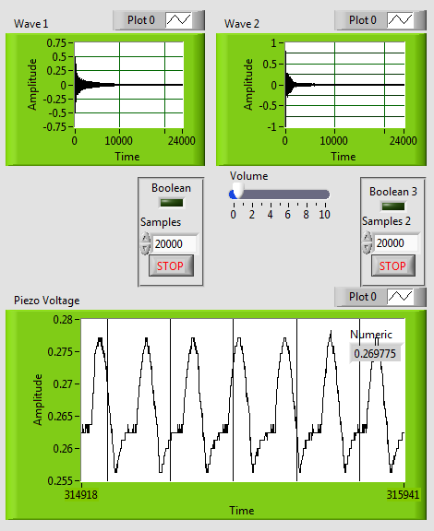

Figure 1. Front Panel of LabView Code when testing piezo sensors.

Wave 1 shows the sound waveform of the first piezo (one being tested through the analog pin)

Wave 2 shows the sound waveform of the second piezo (being tested through digital pin)

Piezo voltage shows the voltage produced by the piezo which is tested through the analog pin.

# Appendix J

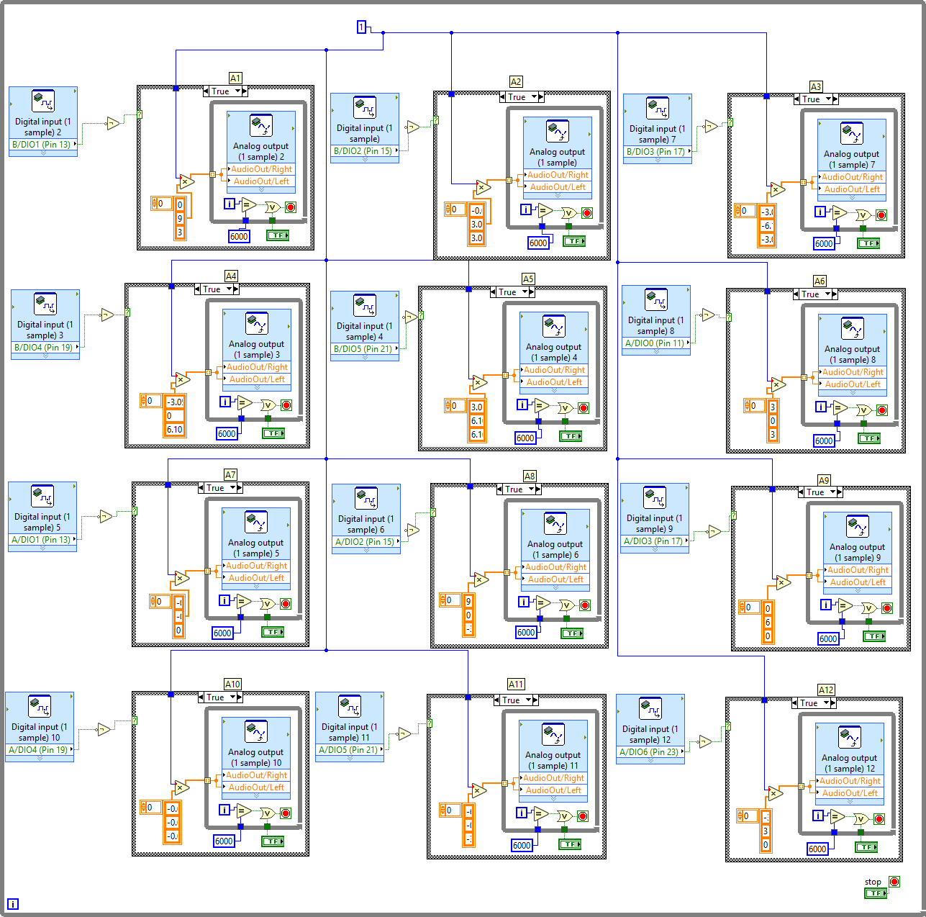

Figure 2. Code for 12 keys to produce 12 notes.

# Appendix K

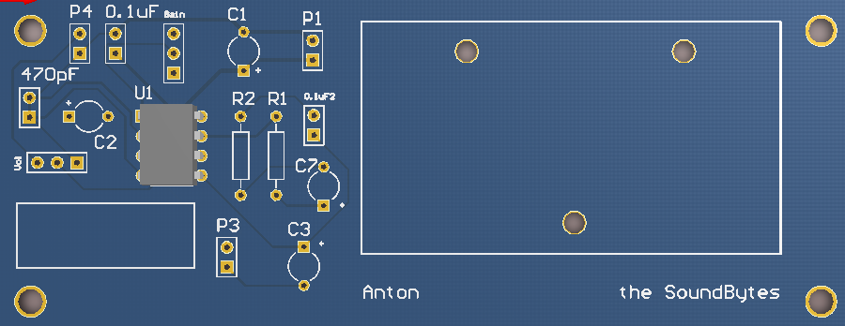

Figure 3. PCB of the audio amplifier circuit